Ideation Phase
Brainstorm & Idea Prioritization Template

Date | 22 February 2026
Team ID | LTVIP2026TMIDS42033
Project Name | Weather-Based Prediction of Wind Turbine Energy Output: A Next-Generation Approach to Renewable Energy Management
Maximum Marks | 4 Marks

Brainstorm & Idea Prioritization Template:
Wind energy is one of the fastest-growing renewable energy sources worldwide. However, wind turbine power output depends heavily on weather conditions such as wind speed, temperature, air pressure, and humidity. Accurate prediction of energy output helps in efficient grid management and renewable energy optimization.
This project aims to develop a machine learning-based predictive model that estimates wind turbine energy output using historical and real-time weather data. The system will support smarter renewable energy management and sustainable planning.
Step-1: Team Gathering, Collaboration and Select the Problem Statement
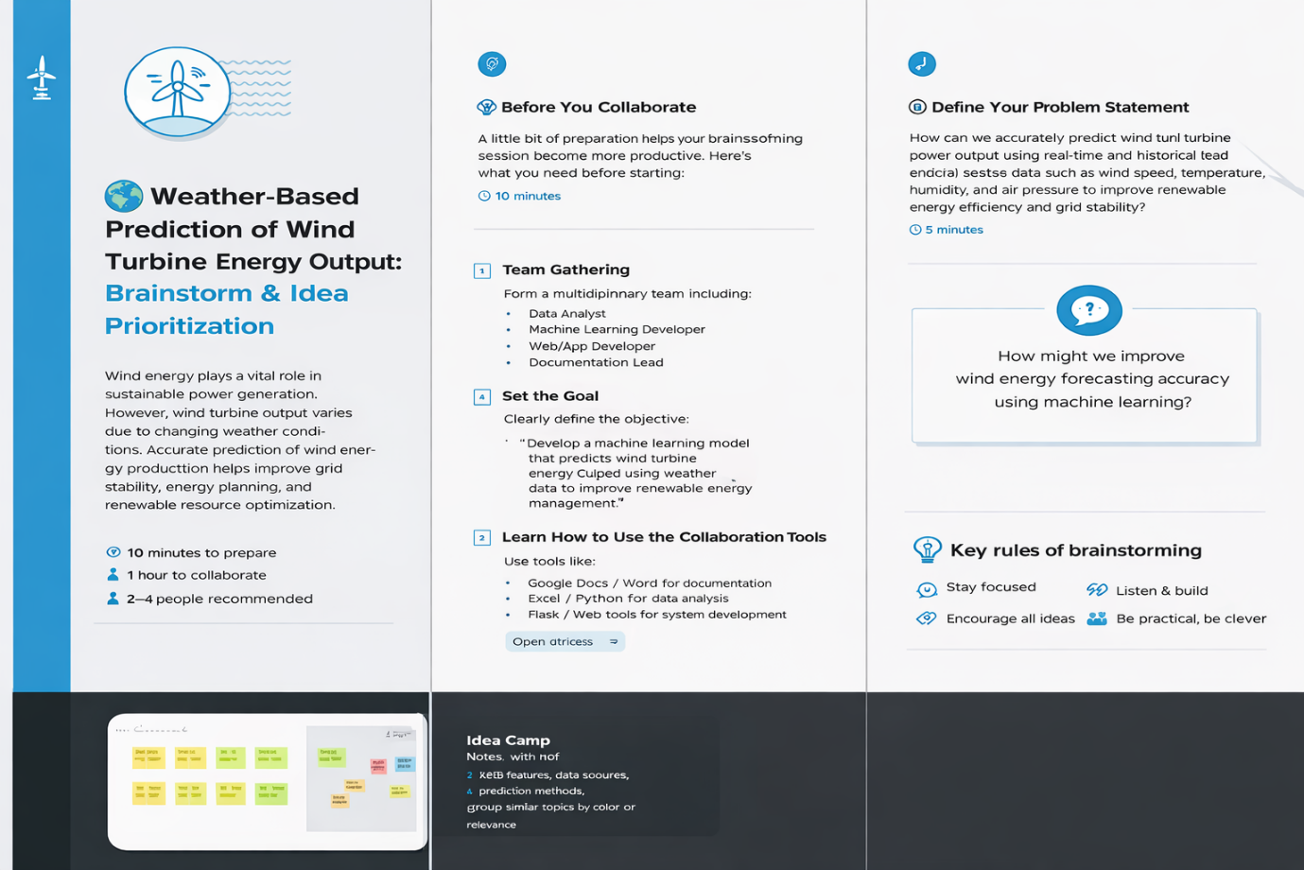

Step-2: Brainstorm, Idea Listing and Grouping
Data & Model Ideas
• Use Wind Turbine SCADA Dataset.
• Collect weather data: Wind Speed, Direction, Temperature, Humidity, Pressure.
• Perform data cleaning and normalization.
• Train models: Linear Regression, Random Forest, XGBoost, SVM.
• Evaluate using R², MAE, RMSE.
System & User-Oriented Features
• Build Flask-based web application.
• Input form for weather parameters.
• Output: Predicted Power Output (kW).
• Display graphs and efficiency indicators.


Step-3: Idea Prioritization
• XGBoost/Random Forest prioritized for high prediction accuracy.
• Web application development marked high priority.
• Prediction dashboard is core functionality.
• Advanced real-time API integration considered future enhancement


